**1** A musical note played by a clarinet is recorded. The signal is shown in the diagram with the time-scale indicated.

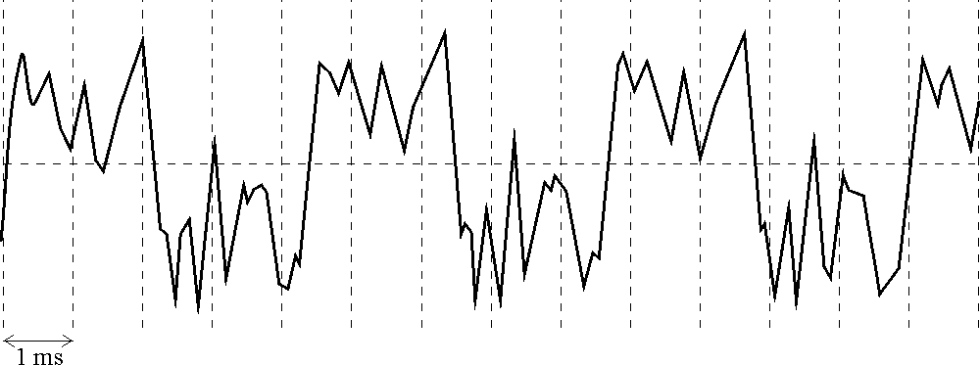

What is the fundamental frequency of the note played by the clarinet, expressed to two significant figures?

**A** 77 Hz

**B** 120 Hz

**C** 230 Hz

**D** 2200 Hz

**Your answer  [1]**

**2** A sound signal is to be digitised for high quality reproduction.

Which of the following statements is/are true?

**1** The sound signal should be sampled at half the highest frequency present in the signal.

**2** The bits per sample determine the resolution of the signal amplitude.

**3** Noise on a digital signal is less problematic than on an analogue signal.

**A** 1, 2 and 3

**B** Only 1 and 2

**C** Only 2 and 3

**D** Only 1

**Your answer  [1]**

**3** A digital camera has 8 megapixels. Each pixel codes 14 bits of information. A photographer requires a memory card which could hold 120 images.

What is the minimum capacity of the card that they should purchase?

**A** 1.7 Mbyte

**B** 13 Mbyte

**C** 1.7 Gbyte

**D** 13 Gbyte

**Your answer  [1]**

**4** A current of 3 μA flows through a resistor for 1.5 minutes.

How much charge flows through the resistor during this time?

**A** 4.5 × 10–6 C

**B** 2.7 × 10–4 C

**C** 4.5 × 10–3 C

**D** 2.7 × 10–1 C

**Your answer  [1]**

**5** Two electrical heating coils **L** and **M** are made from wires of the same material. The wires are of equal length but different diameters. **L** runs at twice the voltage of **M** but both coils dissipate the same power.

What is the correct conductance ratio for the two coils *G*L / *G*M?

**A $\frac{1}{4}$**

**B $\frac{1}{2}$**

**C** 2

**D** 4

**Your answer  [1]**

**6** A student correctly uses an ammeter and a voltmeter to measure the resistance of a component. She obtains the readings *I* = 0.38 ± 0.02 A and *V* = 11.75 ± 0.01 V.

What is the best estimate for the resistance value and its uncertainty?

**A** 30.9 ± 1.6 Ω

**B** 30.92 ± 1.63 Ω

**C** 30.92 ± 0.03 Ω

**D** 31 ± 2 Ω

**Your answer  [1]**

**7** A graph is produced of linear force F (y-axis) against extension x (x-axis) for a metal wire of length L and cross-sectional area A. A second wire of the same material has length 4L and cross-sectional area 4A.

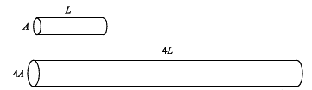

The gradient *k* = *F*/*x* for the second wire will be how many times that for the first wire?

**A** 1

**B** 4

**C** 8

**D** 16

**Your answer  [1]**

**8** Ceramics are brittle materials.

Which of the following statements is/are true?

**1** Slip is prevented in ceramics by impurity atoms pinning dislocations.

**2** Cracks spread because stress is concentrated at the crack tip.

**3** The atoms in the material are bonded in random positions and there are no slip planes.

**A** 1, 2 and 3

**B** Only 1 and 2

**C** Only 2 and 3

**D** Only 1

**Your answer  [1]**

The circuit in **Fig. 9.1** below is referred to in both question 9 and 10.

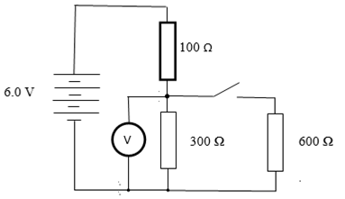

**Fig. 9.1**

**9** The switch in this circuit is open.

What is the potential difference across the 100 Ω resistor?

**A** 1.5 V

**B** 2.0 V

**C** 4.5 V

**D** 6.0 V

**Your answer  [1]**

**10** The switch in **Fig. 9.1** is now closed.

What is the power dissipated in the 100 Ω resistor?

**A** 0.012 W

**B** 0.027 W

**C** 0.040 W

**D** 0.090 W

**Your answer  [1]**

**11 Fig. 27.1** shows a graph of the force against compression for a compression spring.

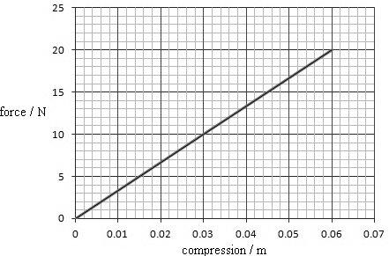

force / N

compression / m

**Fig. 27.1**

State the relationship between force and compression shown by the data in **Fig.27.1**.

…….…………………………………………………………………………..…………….........

..…………………………………………………………………………..……………………….

…………………………………………………………………………..………………….. **[1]**

**12** This question is about the properties and microscopic structure of metal wire. **Fig. 5.1** shows a graph of force against extension for a steel wire.



extension / mm

force / N

**Fig. 5.1**

State how the graph shows that the wire is behaving elastically.

……………………………………………………………………………………………………

……………………………………………………………………………………………… **[1]**

**13** This question is about an experiment performed in AS physics to determine the internal resistance of a battery (two cells combined in series). The experiment can be set up as shown in **Fig. 6.1**.

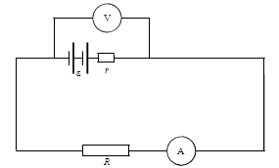

**Fig. 6.1**

Measurements of p.d. *V* and current *I* for a range of values of resistors *R* are taken in order to determine a value for the combined internal resistance of the cells.

In planning the experiment it is important to select suitable equipment.

1. Explain why the following equipment was chosen

**•** A voltmeter with very high internal resistance.

**•** An ammeter with negligible internal resistance.

…………………………………………………………………………………..…………

……………………………………………………………………………………...………

……………………………………………………………………………………………...

……………………………………………………………………………………..… **[2]**

**(b)** A student suggests that using much higher value resistors will improve the quality of measurements by reducing the uncertainty in the current readings.

Comment on this suggestion. Explain your reasoning.

………………………………………………………………………………..……………

……………………………………………………………………………………..………

…………………………………………………………………………………..………...

…………………………………………………………………………………………..…

………………………………………………………………………………………… **[3]**

**(c)** Data obtained from the experiment on page 8 is given in the table below

|  |  |
| --- | --- |
| **p.d. / V** | ***I* /mA** |
| 2.86 | 286 |
| 2.82 | 352 |
| 2.78 | 462 |
| 2.66 | 666 |
| 2.40 | 1200 |

Plot a graph of the values on **Fig. 6.2**. Draw a suitable line.

|  |  |  |  |
| --- | --- | --- | --- |
|  |  | | |
|  |
|  |
|  |
|  |
|  |
|  |
|  |  |  |  |

3.1

3.0

2.9

**p.d./ V**

2.8

2.7

2.6

2.5

2.4

0 500 1000 1500

***I / mA***

**Fig. 6.2**

**[2]**

The equation relating p.d. *V* and current is

*V* = *ɛ* – *Ir*

Where *ɛ* is the e.m.f. of the battery and *r* is the internal resistance of the battery.

**(d)** Use the graph to determine a value for the e.m.f. *ɛ* for the cells. Show your working clearly and include the unit in your answer.

e.m.f. *ɛ* = ………………….. **[2]**

**(e)** Determine a value for the internal resistance.

internal resistance = ………………….. Ω **[3]**

**(f)** A student suggests three possible variations to extend the experiment.

**1)** Adding a switch into the circuit so that the circuit can be disconnected between readings.

**2)** Adding another cell.

**3)** Reversing one of the cells.

Discuss the effect that each of these three suggested changes would have on the accuracy of the experiment, the uncertainty of measurement and the data collected.

……………………………………………………………………………………………

……………………………………………………………………………………………

……………………………………………………………………………………………

……………………………………………………………………………………………

……………………………………………………………………………………………

……………………………………………………………………………………………

……………………………………………………………………………………………

……………………………………………………………………………………………

……………………………………………………………………………………………

……………………………………………………………………………………………

……………………………………………………………………………………………

……………………………………………………………………………………………

……………………………………………………………………………………………

……………………………………………………………………………………………

……………………………………………………………………………………… **[6]**

**14** A camera lens has a focal length of 0.20 m.

**(a)** Calculate the power of the lens in dioptres. Make your method clear.

power of lens = ...................................................... D **[2]**

1. Light waves with a curvature of –0.4 dioptres are incident on this lens.

Calculate the curvature of the waves leaving the lens.

Make your method clear.

curvature of waves leaving lens = ...................................................... D **[2]**

**15** Here is a list of units.

**m–1 m–2 m–3 kg m–3 s–1**

Choose the correct unit for the following quantities:

frequency .............................................

lens power .............................................

charge carrier density .............................................

**[3]**

**16** A single musical note is played on an oboe.

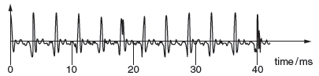

**Fig. 2.1**

**Fig. 2.1** shows the waveform of the note over a time interval of about 40 ms.

**(a)** State how the waveform shows that the note has a definite pitch (fundamental frequency) but that it also contains more than one frequency component.

**[2]**

**(b)** Calculate the frequency of the largest amplitude component of the note.

frequency = .................................................... Hz **[1]**

**17** Here is a list of orders of magnitude.

**106 103 1 10–3 10–6**

State the best estimate for

**(a)** the density in kg m–3 of wood .............................

**(b)** the mass in kg of a 1 mm diameter raindrop .............................

**(c)** the wavelength in m of infra red radiation just beyond the visible spectrum

.............................

**[3]**

**18** This question is about the article Simple measurements using a temperature sensor.

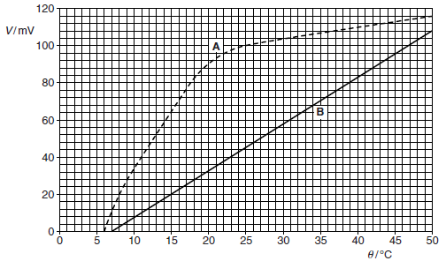

**Fig. 11.1**

**(a)** Calculate the average sensitivity of each sensor shown in **Fig. 11.1** over the range 10**°** to 20°C.

sensitivity of sensor A = ....................................... unit ...............

sensitivity of sensor B = ...................................... unit ...............

**[3]**

**(b) (i)** The voltmeter used to record the p.d. across sensor B reads to the nearest 0.1 mV. Show that the resolution of the sensor is about 0.04°C.

**[2]**

**(ii)** In an experiment to measure the change of water temperature in a bath, sensor B records a change of output of 100 mV.

Calculate the overall temperature change. Give your answer to an appropriate number of significant figures.

temperature change = .................................................... °C **[2]**

**[Total Marks: 50]**

**MARK SCHEME**

| **Question** | **Mks** | **Answer** | **Question Source and Guidance Notes** | **Topics** | **Demand** |
| --- | --- | --- | --- | --- | --- |
| **1** | 1 | C | *Q4 - GCE - Physics B - Specimen - H157/01* | Communication; Imaging and signalling | M |
| **2** | 1 | C | *Q5 - GCE - Physics B - Specimen - H157/01* | Communication; Imaging and signalling | M |
| **3** | 1 | C | *Q6 - GCE - Physics B - Specimen - H157/01* | Communication; Imaging and signalling | L |
| **4** | 1 | B | *Q7 - GCE - Physics B - Specimen - H157/01* | Communication; Sensing | L |
| **5** | 1 | A | *Q8 - GCE - Physics B - Specimen - H157/01* | Communication; Sensing | H |
| **6** | 1 | D | *Q12 - GCE - Physics B - Specimen - H157/01* | Communication; Sensing; Practical skills assessed in a written examination; Evaluation | M |
| **7** | 1 | A | *Q13 - GCE - Physics B - Specimen - H157/01* | Mechanical properties of materials | H |
| **8** | 1 | C | *Q14 - GCE - Physics B - Specimen - H157/01* | Mechanical properties of materials | L |
| **9** | 1 | A | *Q9 - GCE - Physics B - Specimen - H157/01* | Communication; Sensing | M |
| **10** | 1 | C | *Q10 - GCE - Physics B - Specimen - H157/01* | Communication; Sensing | M |
| **11** | 1 | *F* α *x* or force directly proportional to compression or linear and through origin ✓ | *Q27(a) - GCE - Physics B - Specimen - H157/01*  **accept** proportionalities with variables reversed | Mechanical properties of materials | L |
| **12** | 1 | Graph is straight line through origin/ force is proportional to  extension. ✓ | *Q5(a) - GCE - Physics B - Specimen - H157/02* | Mechanical properties of materials | L |
| **13(a)** | 2 | High resistance means that negligible current flows through the voltmeter ✓  Negligible resistance means that pd across the ammeter is minimal/reduced so that it does not affect the readings ✓ | *Q6(a) - GCE - Physics B - Specimen - H157/02*  Or resistance of voltmeter-resistor pair is v. close to that of the resistor alone. | Communication; Sensing; Practical skills assessed in a written examination; Planning | M |
| **13(b)** | 3 | (Suggestion is incorrect)  Increased resistance gives lower current ✓  Constant absolute uncertainty AW ✓ with lower current values give a higher % uncertainty ✓ | *Q6(b) - GCE - Physics B - Specimen - H157/02* | Communication; Sensing; Practical skills assessed in a written examination; Planning; Evaluation | M,H |
| **13(c)** | 2 | Points plotted correctly ✓  Correct line of best fit drawn ✓ | *Q6(c) - GCE - Physics B - Specimen - H157/02* | Communication; Sensing; Practical skills assessed in a written examination; Analysis | L,M |
| **13(d)** | 2 | 3 (V) ✓  correct unit (V) ✓ | *Q6(d) - GCE – Physics B - Specimen - H157/02*  **Allow** ± 0.1V. ecf for their line of best fit. | Communication; Sensing; Practical skills assessed in a written examination; Analysis | M |
| **13(e)** | 3 | Correct method for calculating gradient x values > 750 mA ✓  0.5Ω ✓ | *Q6(e) - GCE - Physics B - Specimen - H157/02*  **Allow** ±0.1Ω | Communication; Sensing | L,M |
| **13(f)** | 6 | **Level 3 (5–6 marks)**  Constructs argument in a clear manner giving clear reasoning at all points. Each part of the question fully covered and the connection made with data on the graph.  *There is a well-developed line of reasoning which is clear and logically structured. The information presented is relevant and substantiated.*  **Level 2 (3–4 marks)**  Covers at least two aspects of the argument. May not link the aspects together. Shows understanding of the effect on uncertainties.  *There is a line of reasoning presented with some structure. The information presented is in the most-part relevant and supported by some evidence.*  **Level 1 (1-2 marks)**  Makes at least two independent points that are relevant to the argument. Structuring of the answer may be poor.  *The information is basic and communicated in an unstructured way. The information is supported by limited evidence and the relationship to the evidence may not be clear.*  **0 marks**  No response or no response worthy of credit. | *Q6f - GCE - Physics B - Specimen - H157/02*  **Indicative scientific points may include:**  **Adding switch**  • Idea of reducing heating effect  • No energy lost/draining of the battery/cells.  • Improved reliability  **Adding another cell**  • Increase in pd -> increase in current  • Change to the overall resistance  • % uncertainty in current reading reduces  • Graph would have a steeper gradient and higher  intercept  **Reversing the cell**  • Reduces the pd -> reduces the current flow  • % uncertainty would increase.   * Overall internal resistance would be the same   • Would produce a lower intercept but same  gradient. | Communication; Sensing; Practical skills assessed in a written examination; Evaluation | M,H |
| **14(a)** | 2 | P = 1/f / 1/0.2 ; 5.(0) (D) | *Q2(a) - GCE - Physics B - June 2013 - G491/01*  method ; evaluation | Communication; Imaging and signalling | L,M |
| **14(b)** | 2 | curvature = -0.4 + 5.0 /  curvature out = curvature in + curvature added by lens ;  = 4.6 (D) | *Q2(b) - GCE - Physics B - June 2013 - G491/01*  method accept words curvature added by lens / state equation 1 / *v* = 1/ u + 1/ f in this format / numbers  evaluation allow ecf on (a) | Communication; Imaging and signalling | L,M |
| **15** | 3 | s-1 ; m-1 ; m-3 | *Q1 - GCE - Physics B - June 2014 - G491/01*  **not** equivalent units not listed e.g. Hz / D | Communication; Imaging and signalling | L,M,H |
| **16(a)** | 2 | waveform is periodic / (main peaks) repeats itself regularly ;  but more complex than pure sine wave / has harmonics / higher frequency (oscillations) / other (smaller) oscillations / smaller peaks (between large ones) | *Q2(a) - GCE - Physics B - June 2014 - G491/01*  idea of time required not constant wavelength or reference to length not just reference to repeated main peaks  **not** smaller frequencies / noise | Communication; Imaging and signalling | L,M |
| **16(b)** | 1 | evaluation (11 x 1000 / 40) = 275 ≈ 280 (Hz) | *Q2(b) - GCE - Physics B - June 2014 - G491/01*  (11 waves in 40 ms / 3.6 ms / wave )  accept answers in range 270 to 280 Hz | Communication; Imaging and signalling | M |
| **17** | 3 | 103 ; 10-6 ; 10-6 | *Q4 - GCE - Physics B - June 2014 - G491/01* | Communication; Imaging and signalling; Sensing | M,H |
| **18(a)** | 3 | Sensor A (90-34)/(20 -10) = 56/10 = 5.6 (1);  Sensor B (33-8)/(20 -10) = 25/10 = 2.5 (1);  units for both are mV °C -1 or mV/°C (1) | *Q11(a) - GCE - Physics B - June 2013 - G492/01*  **Allow** ± 2 on Δ V, i.e. 5.4-5.8  & 2.3 to 2.7 respectively  sensitivity of B can be measured over any range  **allow** eg V °C -1 if attempt at conversion made, even if incorrectly done | Communication; Sensing | L,M |
| **18(b)(i)** | 2 | 2.6 mV ∼ 1 °C ⇒ 0.1 mV ∼ 0.1/2.6 °C = 0.0385 °C (1)m; (1)e | *Q11(c)(i) - GCE - Physics B - June 2013 - G492/01*  **ecf from (a).** | Communication; Sensing | L,M |
| **20(c)(ii)** | 2 | Δθ =100 mV/sensitivity of sensor B (2.5 mV oC -1)  Or determine Δθ from any two points 100 mV apart (1) m;  answer in range 38 °C to 42 °C (1)e | *Q11(c)(ii) - GCE - Physics B - June 2013 - G492/01*  eg (47,100) and (7,0) – may need to check graph  bald answer in range gets 2 marks  no evaluation mark if > 3 sig figs |
| **Total** | **50** |  |  |  |  |

**OCR Resources**: *the small print*OCR’s resources are provided to support the teaching of OCR specifications, but in no way constitute an endorsed teaching method that is required by the Board, and the decision to use them lies with the individual teacher. Whilst every effort is made to ensure the accuracy of the content, OCR cannot be held responsible for any errors or omissions within these resources. We update our resources on a regular basis, so please check the OCR website to ensure you have the most up to date version.  
© OCR 2016

**OCR Resources**: *the small print*OCR’s resources are provided to support the teaching of OCR specifications, but in no way constitute an endorsed teaching method that is required by the Board, and the decision to use them lies with the individual teacher. Whilst every effort is made to ensure the accuracy of the content, OCR cannot be held responsible for any errors or omissions within these resources. We update our resources on a regular basis, so please check the OCR website to ensure you have the most up to date version.  
© OCR 2016 - This resource may be freely copied and distributed, as long as the OCR logo and this message remain intact and OCR is acknowledged as the originator of this work.