Multiple Choice Questions (MCQ) topic quiz

Set 2 Electricity, sensing, waves and quantum physics

Instructions and answers for teachers

These instructions cover the learner activity section which can be found below.
This Lesson Element supports OCR AS and A Level Physics A and OCR AS and A Level Physics B (Advancing Physics).
When distributing the activity section to the students either as a printed copy or as a Word file you will need to remove the teacher instructions section.

The Activity
This Lesson Element is a teaching and learning resource containing 20 multiple choice questions (MCQs) on the theme of electricity, sensing, waves and quantum physics. Some questions might require synoptic thinking, using knowledge and ideas from various topics across the full A Level content.
This resource can be used to test and consolidate understanding at the end of a topic or to revisit and refresh knowledge at a later point in the course.

Introduction
Multiple choice questions allow rapid coverage of a wide range of sub-topics.
Contrary to a widespread belief among students, multiple choice questions are not necessarily easy – they can be easy, moderate or difficult.
The questions are written so that the incorrect answers are plausible distractors based on common errors or misconceptions.
When the developers are writing such questions they have to provide the logic to support their answers and the reasoning for each distractor.

For example for question 8:

A | 1.5 Ω | r = (9.0 – 6.0)/2 = 1.5 Ω
B | 3.0 Ω | r = 6.0/2.0 = 3.0 Ω - resistance of external resistor
C | 4.5 Ω | r = 9.0/2.0 = 4.5 Ω - total resistance of circuit
D  A | 6.0 Ω | r = VI = 3.0 × 2.0 = 6.0 Ω (.... a common misconception)
Your answer

Possible techniques for completion
For calculation questions completing the calculation before looking at the alternative answers can avoid being deflected by the distractors and ensure an impartial response.
For questions involving thinking skills and logical deduction it may be possible to eliminate at least one answer as being a distractor, thus reducing the final choice.
It is not good practice to leave any answer blank, unless the marking for the multiple choice questions includes a penalty for incorrect answers, so it is worthwhile using knowledge or intuition to select what you believe is the most likely answer.

Contents
Teacher section
Multiple Choice Questions topic quiz - answers – Electricity 4
Multiple Choice Questions topic quiz - answers – Electricity – Physics B 7
Multiple Choice Questions topic quiz - answers – Electricity 8
Multiple Choice Questions topic quiz - answers – Oscilloscope 12
Multiple Choice Questions topic quiz - answers – Waves 13
Multiple Choice Questions topic quiz - answers – Waves – (Physics B) 16
Multiple Choice Questions topic quiz - answers – Quantum physics 17
Learner resources
Multiple Choice Questions (MCQ) topic quiz – Electricity 20
Multiple Choice Questions (MCQ) topic quiz– Electricity – Physics B 23
Multiple Choice Questions (MCQ) topic quiz– Electricity 24
Multiple Choice Questions (MCQ) topic quiz - Oscilloscope 28
Multiple Choice Questions (MCQ) topic quiz – Waves 29
Multiple Choice Questions (MCQ) topic quiz – Waves – (Physics B) 32
Multiple Choice Questions (MCQ) topic quiz – Quantum physics 33

Multiple Choice Questions topic quiz - answers – Electricity

1. A current of 3.0 μA flows through a resistor in 1.5 minutes.
How much charge flows through the resistor in this time?
A | 4.5 x 10⁻⁶ C
B | 2.7 x 10⁻⁴ C
C | 4.5 x 10⁻³ C
D  B | 2.7 x 10⁻¹ C
Your answer
2. In the circuit shown, a potential difference of 3V is applied across XY.
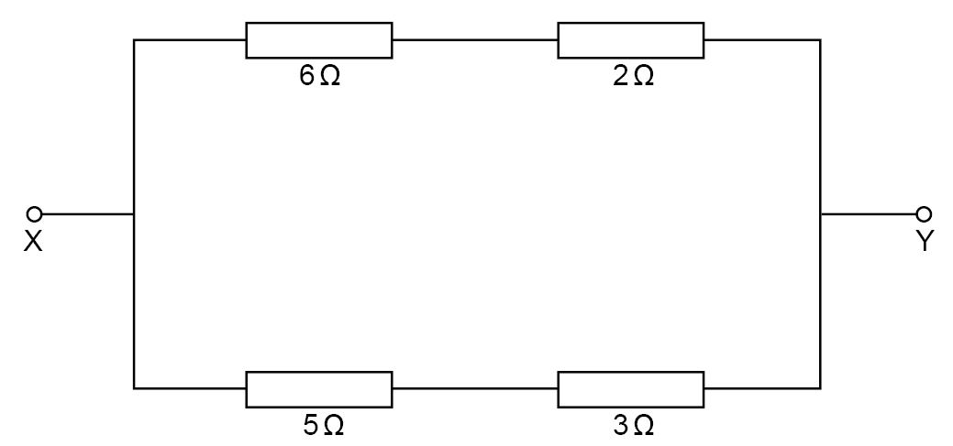

What is the current in the 5 Ω resistor?
A | 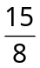A
B | A
C | A
D  D | A
Your answer

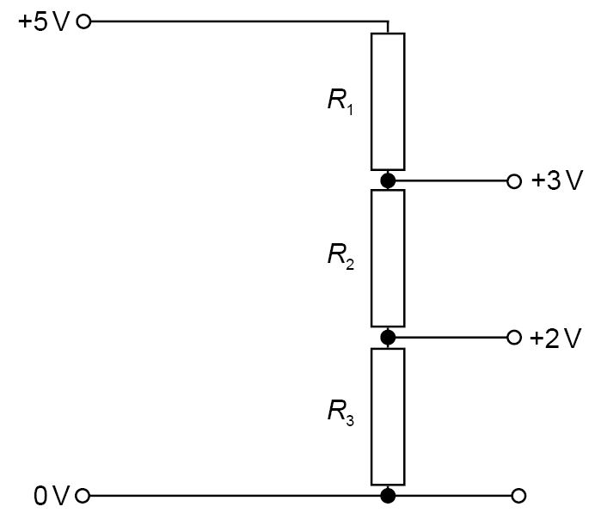
3. A potential divider is used to give outputs of 2 V and 3 V from a 5 V source as shown..

Which combination of resistors R₁, R₂, R₃, gives the correct voltages?
 | R₁ / kΩ | R₂ / kΩ | R₃ / kΩ
A | 1 | 1 | 2
B | 2 | 1 | 2
C | 3 | 2 | 2
D  B | 3 | 2 | 3
Your answer

4. The resistors P, Q and R in the circuit have equal resistance.
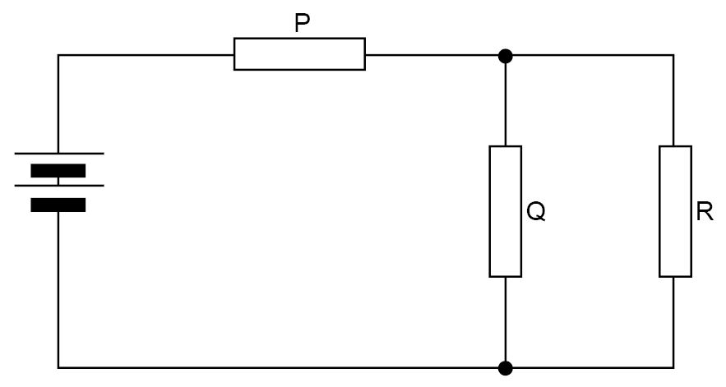

The battery, of negligible internal resistance, supplies a total power of 12W.
What is the power dissipated in resistor R?
A | 2 W
B | 3 W
C | 4 W
D  A | 5 W
Your answer

Multiple Choice Questions topic quiz - answers – Electricity – Physics B

5. Two conductors, of conductances 0.24 S and 0.36 S, are connected in parallel to a 4.5 V battery of negligible internal resistance as shown below.
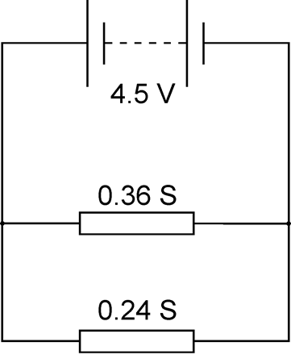

What is the total power dissipated in the two conductors?
A | 2.9 W
B | 4.9 W
C | 7.3 W
D  D | 12 W
Your answer

Multiple Choice Questions topic quiz - answers – Electricity

6. An unknown resistor R and a 220 Ω resistor are connected to a 6.0 V battery of negligible internal resistance as shown in the diagram below.
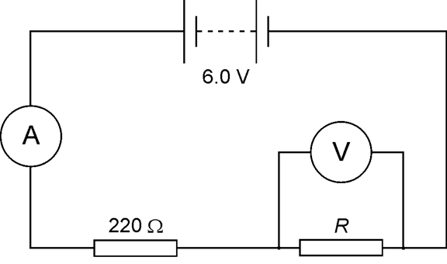

The reading on the voltmeter is 4.1 V.
What is the reading on the ammeter?
A | 8.6 mA
B | 13 mA
C | 19 mA
D  A | 27 mA
Your answer

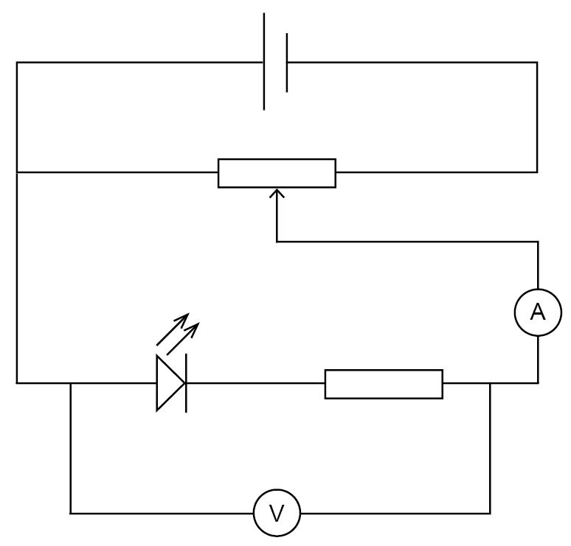
7. A student wants to determine the threshold voltage of a light-emitting diode (LED). During the investigation the LED is lit. The student then attempts to draw the circuit he has used as shown below.

What mistake has the student has made in his circuit diagram?
A | The ammeter should be before the LED and resistor.
B | The fixed resistor should be in parallel with the LED.
C | The LED is the incorrect way around.
D  D | The voltmeter connections are incorrect.
Your answer

8. A battery is connected across resistor R via a switch S.
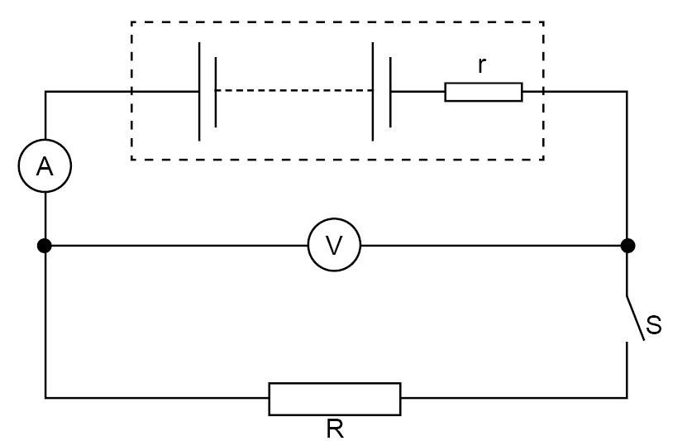

The switch S is open. The voltmeter reading is 9.0 V and the ammeter reading is zero.
With S closed, the voltmeter reading is 6.0 V and ammeter reading is 2.0 A.
What is the internal resistance of the battery?

A | 1.5 Ω
B | 3.0 Ω
C | 4.5 Ω
D  A | 6.0 Ω
Your answer

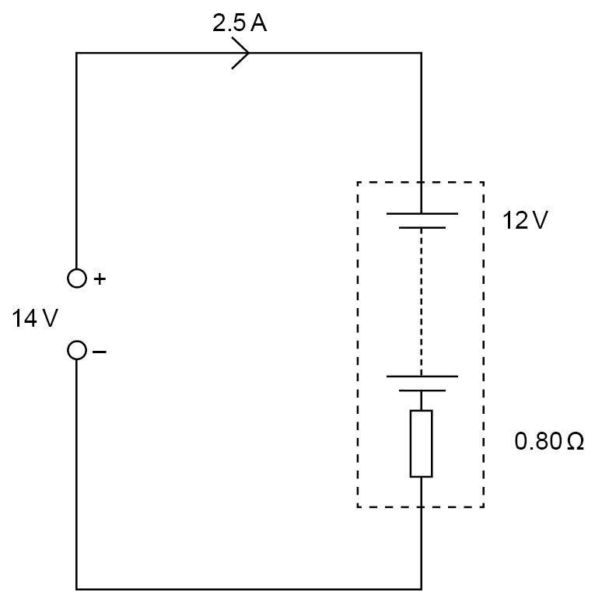
9. A 14 V d.c. supply is used to charge a 12 V car battery of internal resistance 0.80 Ω at a rate of 2.5 A for 6 hours.

How much electrical energy is provided by the charging supply?
A | 13 kJ
B | 110 kJ
C | 650 kJ
D  D | 760 kJ
Your answer

Multiple Choice Questions topic quiz - answers – Oscilloscope

10. The y-input terminals of an oscilloscope are connected to a voltage supply of peak value 5.0 V and frequency 50 Hz.
The time-base is set at 10 ms per division and the y axis is set at 5.0 V per division.
Assuming that these diagrams are to scale, which trace will be obtained?

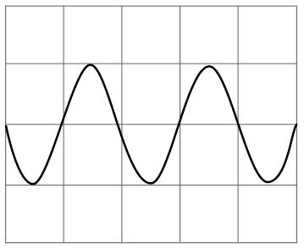  A | 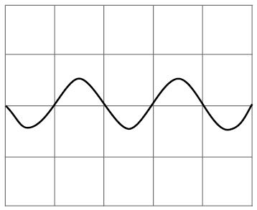  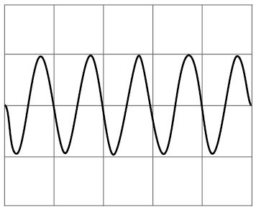  B
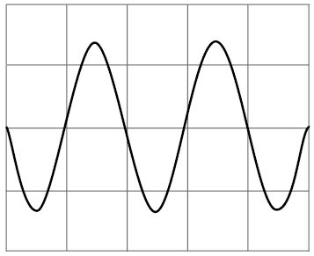  C | D

A
Your answer

Multiple Choice Questions topic quiz - answers – Waves

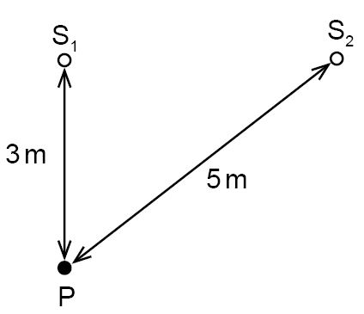
11. Water waves of wavelength 4m are produced by two wave generators, S₁ and S₂, as shown.
Each generator, when operated by itself, produces waves which have an amplitude A at P, which is 3m from S₁ and 5m from S₂.

When the generators are operated in phase, what is the amplitude of oscillation at P?
A | 0
B | ½ A
C | A
D  A | 2A
Your answer

12. Which group of electromagnetic waves is arranged in order of increasing frequency?
lowest frequency highest frequency

A | gamma rays, ultra-violet rays, radio waves
B | microwaves, ultra-violet rays, X-rays
C | radio waves, visible light, infra-red radiation
D  B | Visible light, infra-red radiation, microwaves
Your answer
13. In the diagram, T represents a transmitter of microwaves and P represents a metal plate.
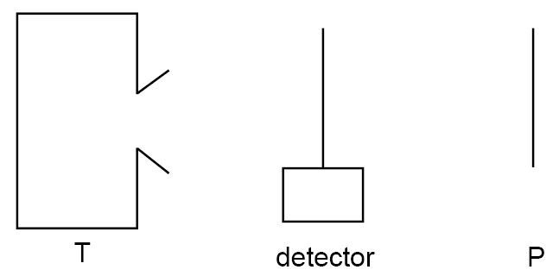

The detector is connected to a meter which gives a reading proportional to the signal strength at that point. The distance TP is much greater than the wavelength of the microwaves.
As the detector is moved from T to P what happens to the meter reading?

A | It decreases steadily
B | It reaches a maximum at P
C | It reaches a maximum midway between T and P
D  D | It increases and decreases rapidly
Your answer

14. Light of wavelength 600 nm falls on a pair of slits, forming fringes 3.00 mm apart on a screen.
What would the fringe spacing become if the wavelength were 300 nm?
A | 0.75 mm
B | 1.50 mm
C | 3.00 mm
D  B | 6.00 mm
Your answer

15. A ray of light passes from air into a rectangular glass block.
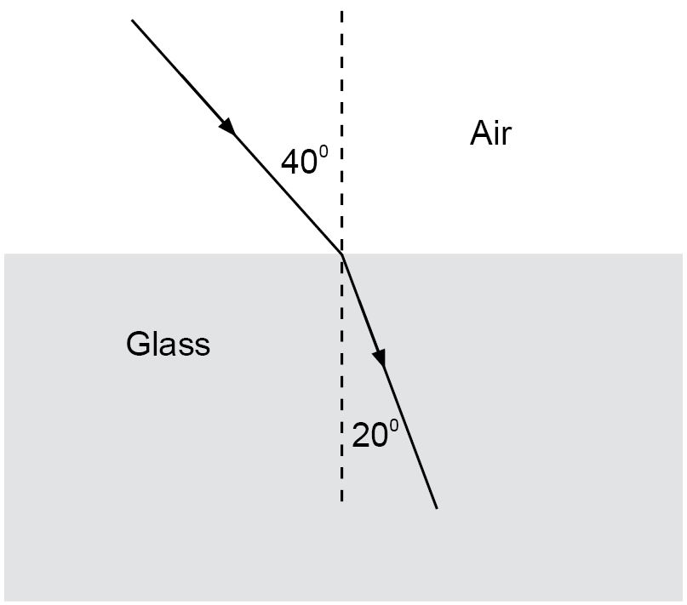

The refractive index of the glass is:
A | 0.53
B | 0.82
C | 1.2
D  D | 1.9
Your answer

Multiple Choice Questions topic quiz - answers – Waves – (Physics B)

16. A lamp is placed 0.50 m from a converging lens. The power of the lens is +5.0 D.
What is the distance from the lens to the focused image?

A | 0.14 m
B | 0.20 m
C | 0.33 m
D  C | 0.45 m
Your answer

Multiple Choice Questions topic quiz - answers
– Quantum physics

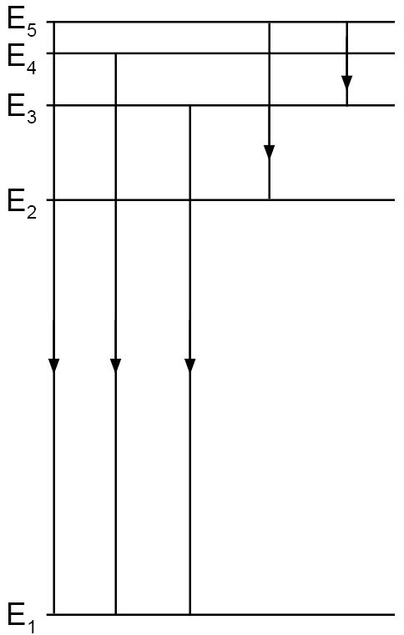
17. The diagram shows five energy levels of electrons within an atom. Five possible transitions between the levels are indicated. Each transition produces a photon of specific energy and frequency.

Which of the following spectra corresponds most closely to the transition shown?
increasing frequency

A | 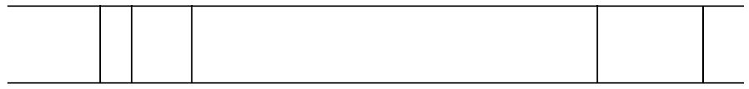
B | 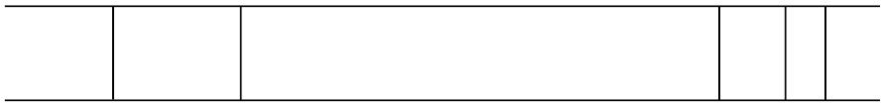
C | 
D  B | 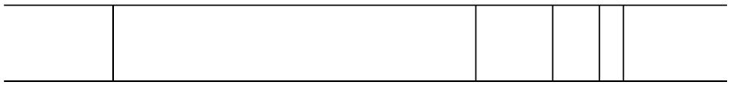
Your answer

18. The up quark (u) has charge + ⅔ e and the down quark (d) a charge of – ⅓ e.
What is the correct combination of quarks that make up the proton and the neutron?
 | proton | neutron
A | ddd | uud
B | udd | uud
C | uud | udd
D  C | ddd | udd
Your answer

19. An electron has a kinetic energy of 2.0 x 10⁻¹⁷ J.
The mass of an electron is 9.1 x 10⁻³¹ kg.
What is the value for the de Broglie wavelength of the electron?
A | 1.1 x 10⁻¹⁰
B | 1.5 x 10⁻¹⁰ m
C | 3.3 x 10⁻¹⁷ m
D  A | 6.6 x 10⁻¹⁷ m
Your answer

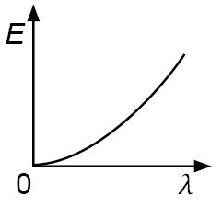
20. Which curve shows the relationship between the energy E and the wavelength λ of a photon of electromagnetic radiation?
A B | 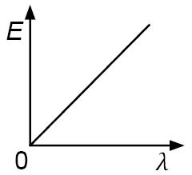
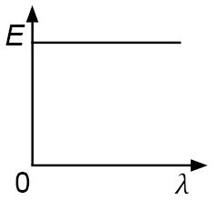
C D 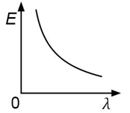
D
Your answer
OCR Resources: the small print
OCR’s resources are provided to support the teaching of OCR specifications, but in no way constitute an endorsed teaching method that is required by the Board, and the decision to use them lies with the individual teacher. Whilst every effort is made to ensure the accuracy of the content, OCR cannot be held responsible for any errors or omissions within these resources.
© OCR 2015 - This resource may be freely copied and distributed, as long as the OCR logo and this message remain intact and OCR is acknowledged as the originator of this work.
OCR acknowledges the use of the following content: n/a
Please get in touch if you want to discuss the accessibility of resources we offer to support delivery of our qualifications: resources.feedback@ocr.org.uk
OCR Resources: the small print
OCR’s resources are provided to support the teaching of OCR specifications, but in no way constitute an endorsed teaching method that is required by the Board, and the decision to use them lies with the individual teacher. Whilst every effort is made to ensure the accuracy of the content, OCR cannot be held responsible for any errors or omissions within these resources.
© OCR 2016 - This resource may be freely copied and distributed, as long as the OCR logo and this message remain intact and OCR is acknowledged as the originator of this work.
OCR acknowledges the use of the following content: n/a
Please get in touch if you want to discuss the accessibility of resources we offer to support delivery of our qualifications: resources.feedback@ocr.org.uk
We’d like to know your view on the resources we produce. By clicking on ‘Like’ or ‘Dislike’ you can help us to ensure that our resources work for you. When the email template pops up please add additional comments if you wish and then just click ‘Send’. Thank you.
If you do not currently offer this OCR qualification but would like to do so, please complete the Expression of Interest Form which can be found here: www.ocr.org.uk/expression-of-interest
We’d like to know your view on the resources we produce. By clicking on ‘Like’ or ‘Dislike’ you can help us to ensure that our resources work for you. When the email template pops up please add additional comments if you wish and then just click ‘Send’. Thank you.
If you do not currently offer this OCR qualification but would like to do so, please complete the Expression of Interest Form which can be found here: www.ocr.org.uk/expression-of-interest
This formative assessment resource has been produced as part of our free Physics teaching and learning support package. All the Physics teaching and learning resources, including delivery guides, topic exploration packs, lesson elements and more are available on the qualification webpages.
If you are looking for examination practice materials, you can find Sample Assessment Materials (SAMs) and a link to the Practice Papers on the qualification webpages: Physics A, Physics B.

Learner resources

Multiple Choice Questions (MCQ) topic quiz

– Electricity

1. A current of 3.0 μA flows through a resistor in 1.5 minutes.
How much charge flows through the resistor in this time?
A | 4.5 x 10⁻⁶ C
B | 2.7 x 10⁻⁴ C
C | 4.5 x 10⁻³ C
D | 2.7 x 10⁻¹ C
Your answer

2. In the circuit shown, a potential difference of 3V is applied across XY.

What is the current in the 5 Ω resistor?
A | A
B | A
C | A
D | A
Your answer
3. A potential divider is used to give outputs of 2 V and 3 V from a 5 V source as shown..

Which combination of resistors R₁, R₂, R₃, gives the correct voltages?
 | R₁ / kΩ | R₂ / kΩ | R₃ / kΩ
A | 1 | 1 | 2
B | 2 | 1 | 2
C | 3 | 2 | 2
D | 3 | 2 | 3
Your answer

4. The resistors P, Q and R in the circuit have equal resistance.

The battery, of negligible internal resistance, supplies a total power of 12W.
What is the power dissipated in resistor R?
A | 2 W
B | 3 W
C | 4 W
D | 5 W
Your answer

Multiple Choice Questions (MCQ) topic quiz– Electricity – Physics B

5. Two conductors, of conductances 0.24 S and 0.36 S, are connected in parallel to a 4.5 V battery of negligible internal resistance as shown below.

What is the total power dissipated in the two conductors?
A | 2.9 W
B | 4.9 W
C | 7.3 W
D | 12 W
Your answer

Multiple Choice Questions (MCQ) topic quiz– Electricity

6. An unknown resistor R and a 220 Ω resistor are connected to a 6.0 V battery of negligible internal resistance as shown in the diagram below.

The reading on the voltmeter is 4.1 V.
What is the reading on the ammeter?
A | 8.6 mA
B | 13 mA
C | 19 mA
D | 27 mA
Your answer

7. A student wants to determine the threshold voltage of a light-emitting diode (LED). During the investigation the LED is lit. The student then attempts to draw the circuit he has used as shown below.

What mistake has the student has made in his circuit diagram?
A | The ammeter should be before the LED and resistor.
B | The fixed resistor should be in parallel with the LED.
C | The LED is the incorrect way around.
D | The voltmeter connections are incorrect.
Your answer

8. A battery is connected across resistor R via a switch S.

The switch S is open. The voltmeter reading is 9.0 V and the ammeter reading is zero.
With S closed, the voltmeter reading is 6.0 V and ammeter reading is 2.0 A.
What is the internal resistance of the battery?

A | 1.5 Ω
B | 3.0 Ω
C | 4.5 Ω
D | 6.0 Ω
Your answer

9. A 14 V d.c. supply is used to charge a 12 V car battery of internal resistance 0.80 Ω at a rate of 2.5 A for 6 hours.

How much electrical energy is provided by the charging supply?
A | 13 kJ
B | 110 kJ
C | 650 kJ
D | 760 kJ
Your answer

Multiple Choice Questions (MCQ) topic quiz - Oscilloscope

10. The y-input terminals of an oscilloscope are connected to a voltage supply of peak value 5.0 V and frequency 50 Hz.
The time-base is set at 10 ms per division and the y axis is set at 5.0 V per division.
Assuming that these diagrams are to scale, which trace will be obtained?

A | B
C | D
Your answer

Multiple Choice Questions (MCQ) topic quiz – Waves

11. Water waves of wavelength 4 m are produced by two wave generators, S₁ and S₂, as shown.
Each generator, when operated by itself, produces waves which have an amplitude A at P, which is 3m from S₁ and 5m from S₂.

When the generators are operated in phase, what is the amplitude of oscillation at P?
A | 0
B | ½ A
C | A
D | 2A
Your answer

12. Which group of electromagnetic waves is arranged in order of increasing frequency?
lowest frequency highest frequency

A | gamma rays, ultra-violet rays, radio waves
B | microwaves, ultra-violet rays, X-rays
C | radio waves, visible light, infra-red radiation
D | Visible light, infra-red radiation, microwaves
Your answer

13. In the diagram, T represents a transmitter of microwaves and P represents a metal plate.

The detector is connected to a meter which gives a reading proportional to the signal strength at that point. The distance TP is much greater than the wavelength of the microwaves.
As the detector is moved from T to P what happens to the meter reading?

A | It decreases steadily
B | It reaches a maximum at P
C | It reaches a maximum midway between T and P
D | It increases and decreases rapidly
Your answer

14. Light of wavelength 600 nm falls on a pair of slits, forming fringes 3.00 mm apart on a screen.
What would the fringe spacing become if the wavelength were 300 nm?
A | 0.75 mm
B | 1.50 mm
C | 3.00 mm
D | 6.00 mm
Your answer

15. A ray of light passes from air into a rectangular glass block.

The refractive index of the glass is:
A | 0.53
B | 0.82
C | 1.2
D | 1.9
Your answer

Multiple Choice Questions (MCQ) topic quiz – Waves – (Physics B)

16. A lamp is placed 0.50 m from a converging lens. The power of the lens is +5.0 D.
What is the distance from the lens to the focused image?

A | 0.14 m
B | 0.20 m
C | 0.33 m
D | 0.45 m
Your answer

Multiple Choice Questions (MCQ) topic quiz

– Quantum physics

17. The diagram shows five energy levels of electrons within an atom. Five possible transitions between the levels are indicated. Each transition produces a photon of specific energy and frequency.

Which of the following spectra corresponds most closely to the transition shown?
increasing frequency

A
B
C
D

Your answer

18. The up quark (u) has charge + ⅔ e and the down quark (d) a charge of – ⅓ e.
What is the correct combination of quarks that make up the proton and the neutron?
 | proton | neutron
A | ddd | uud
B | udd | uud
C | uud | udd
D | ddd | udd
Your answer

19. An electron has a kinetic energy of 2.0 x 10⁻¹⁷ J.
The mass of an electron is 9.1 x 10⁻³¹ kg.
What is the value for the de Broglie wavelength of the electron?
A | 1.1 x 10⁻¹⁰
B | 1.5 x 10⁻¹⁰ m
C | 3.3 x 10⁻¹⁷ m
D | 6.6 x 10⁻¹⁷ m
Your answer

20. Which curve shows the relationship between the energy E and the wavelength λ of a photon of electromagnetic radiation?
B
A

C D

Your answer

