Investigating Terminal Velocity PAG 1.2 __________________________

In this experiment, you will measure the terminal velocity of a ball bearing as it falls through a viscous liquid with the possibility of using this value to determine the viscosity as an extension task.

Aim To determine terminal velocity for an object falling through a viscous liquid

Equipment measuring cylinder, beaker containing viscous liquid, access to a balance and micrometer screw gauge, tube filled with viscous liquid, elastic bands or other method of marking distances along tube, steel ball bearings, magnet, metre rule, stopwatch, paper towels
Suggested Procedure
- Measure the mass of an empty measuring cylinder. Pour some of the viscous liquid into the measuring cylinder. Record the volume of liquid and the new mass of the measuring cylinder.
- Determine the density of the liquid. ρ = m/v
- Measure and record the mass (m) and diameter (d) of the ball bearings.
- Carefully drop a ball bearing into the centre of the liquid and watch it fall as shown in Fig. 1. Establish how far the ball bearing needs to travel in order to reach terminal (constant) velocity.
- Place a pair of elastic bands a known distance apart positioned so that the ball bearing travels at its terminal velocity between them. Use a stopwatch to measure the time it takes for the ball bearing to travel between them.
- Carry out a suitable number of repeats.
- Adjust the distance between the bands and repeat the procedure.
- Repeat for at least 8 distances covering as wide a range as possible.
- Plot a scatter graph with time on the x-axis and distance on the y-axis.
- Calculate a best value for the terminal velocity from the gradient of a line of best fit on the graph.
- Identify the range of values for terminal velocity using lines of worst fit and calculate the maximum percentage variation from your best value.

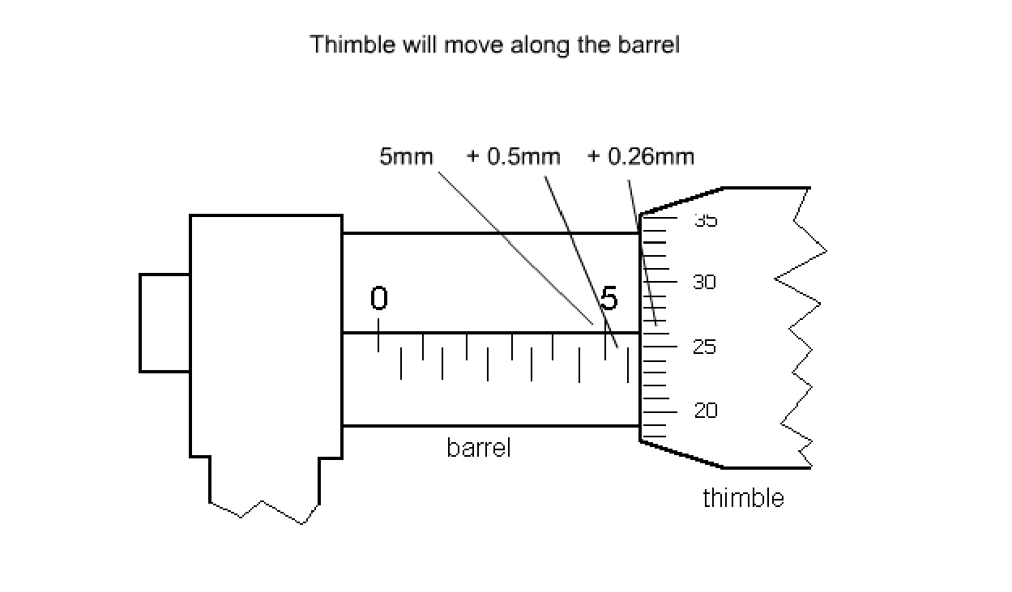

Recording
As evidence for the Practical Endorsement you should have the data collected from your group in a clear and logical format. All work should be clearly dated.

In addition, to support the assessment of practical skills in the written examination and to help you develop your understanding, you have used the data collected to plot a graph to determine the terminal velocity of the ball.

Extension to determine the viscosity of the liquid
Determine a value for the viscosity of the liquid using the equation
43
η = (mg - r ³gρ)
6πr v
Where:
- η = viscosity of liquid | - r = radius of the ball bearing
- m = mass of the ball bearing | - ρ = density of the liquid
- g = acceleration of free fall | - ν = terminal velocity

Evaluating your result
- Comment on the reliability of your value for viscosity by considering your results and possible variations in timings.
- Estimate the error in timing. Estimate the error in your diameter measurements.
- Combine the errors of all measurements to estimate the percentage error in viscosity.

Assessed Criteria

- 1.2.1(b) safely and correctly use a range of practical equipment and materials
- 1.2.1(c) follow written instructions
- 1.2.1(d) make and record observations/measurements
- 1.2.1(e) keep appropriate records of experimental activities
- 1.2.1(f) present information and data in a scientific way
- 1.2.1(j) use a wide range of experimental and practical instruments, equipment and techniques appropriate to the knowledge and understanding included in the specification
- 1.2.2 (a) use analogue apparatus to measure length
- 1.2.2(b) use of appropriate digital instruments to include time…
- 1.2.2(c) use methods to increase accuracy such as a plumbline
- 1.2.2(d) use of stopwatch for timing
- 1.2.2(e) use of calipers and micrometers for small distances, using digital or vernier scales

- CPAC
- Follows written procedures
- Safely uses a range of practical equipment and materials
(4) Makes and records observations

