Investigating Electrical Characteristics 3.2
In this experiment you will be determining the current – voltage characteristic of an electrical component.

Aims: To set up the circuit correctly. To obtain an appropriate set of data. To plot the characteristic Equipment (per group) power supply (max 12V) rheostat, multimeters, leads, test component (filament lamp, diode, resistor)

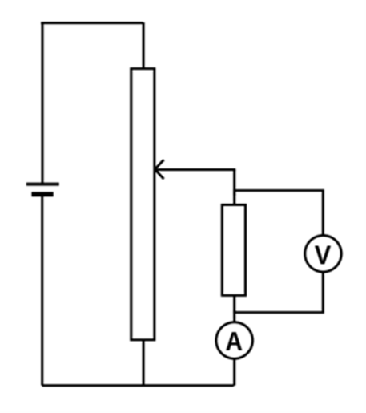
Task
- To measure the characteristic curve for a component you must change the voltage and measure the current, this should include reversing the polarity of the supply to obtain readings for negative voltage.
- Find the maximum and minimum values of voltage that give appropriate readings of current, and then select the steps needed to give the required number of values.
- Measure the current as the voltage is changed across the component.
- Draw the current – voltage curves for your component.
- Calculate the resistance of the component at any point.
- Describe the characteristic of the component with relation to potential difference, current and resistance.
- If there is time, complete a characteristic for both a resistor and diode.

To submit
For this piece of work to count towards Practical Activity Group 3 of the GCE Physics Practical Endorsement you should have evidence of the data collected from your group in a clear and logical format.
You should have a graph and your description of this characteristic.

You will be assessed on the following criteria.

1.2.1 Practical skills
(a) apply investigative approaches and methods to practical work
(b) safely and correctly use a range of practical equipment and materials
(c) follow written instructions
(d) make and record observations/measurements
(e) keep appropriate records of experimental activities
(f) present information and data in a scientific way
(g) use appropriate software and tools to process data, carry out research and report findings
(j) use a wide range of experimental and practical instruments, equipment and techniques appropriate to the knowledge and understanding included in the specification.

1.2.2 Use of apparatus and techniques
(b) use of appropriate digital instruments, including electrical multimeters, to obtain a range of measurements (to include time, current, voltage, resistance and mass)
(f) correctly constructing circuits from circuit diagrams using DC power supplies, cells, and a range of circuit components, including those where polarity is important

Common Practical Assessment Criteria, CPAC
(1) Follows written procedures
(2) Applies investigative approaches and methods when using instruments and equipment
(3) Safely uses a range of practical equipment and materials
(4) Makes and records observations

