4.1 Combining Resistors PAG Name ____________________

Equipment: multimeter + 2 leads + 4 (or more) 1kΩ resistors + 5 croc clips

Label each resistor A, B, C or D with a small strip of sticky label.
Measure the combined resistance of the following combinations.

1. Each resistor on its own.

A | B | C | D

2. Pairs of resistor in series

AB | BA | AC | AD

3. Three resistors in series

ABC | ACB | CAB | BCA

4. Four resistors in series

ABCD | ACBD | DCAB | BDCA

Describe any patterns you have found for resistors in series.

5. Two resistors in parallel

AB | BC | AC | DA

6. Three resistors in parallel

ABC | ABD | ACD | BCD

ABCD
7. All four in parallel

What pattern have you found? ________________________________________________

__________________________________________________________________________

Now predict the resistance of the following combinations and see if you are correct.

Prediction = ____________ Measured Value = ____________

Prediction = ____________ Measured Value = ____________

Prediction = ___________ Measured Value = ____________

Now investigate the resistances across a 2D or 3D arrangement of resistors such as one of the ones below.

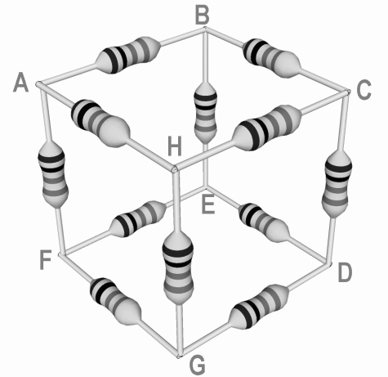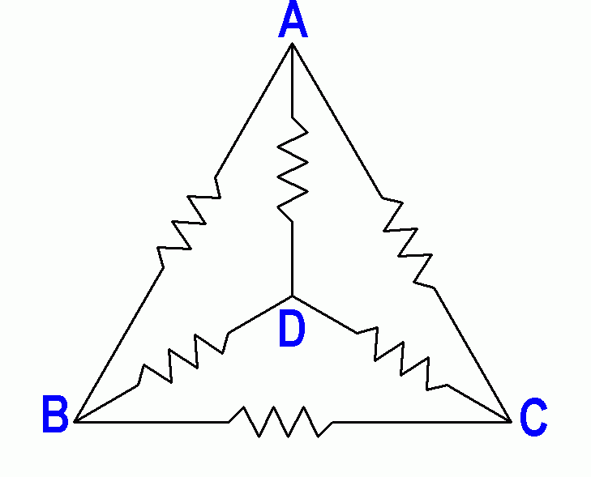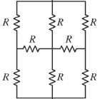

Resistor Arrangement Chosen

Record your findings below.

Conclusions
Aims and skills covered
- To determine the combined value of resistor combinations
- To use appropriate digital meters including multimeters to measure resistance

Practical Skills
- 1.2.1(a) apply investigative approaches and methods to practical work
- 1.2.1(b) safely and correctly use a range of practical equipment and materials
- 1.2.1(c) follow written instructions
- 1.2.1(d) make and record observations/measurements
- 1.2.1(e) keep appropriate records of experimental activities
- 1.2.1(f) present information and data in a scientific way
- 1.2.1(j) use a wide range of experimental and practical instruments, equipment and techniques appropriate to the knowledge and understanding included in the specification
- 1.2.2(b) use of appropriate digital instruments including electrical multimeters to measure resistance
CPAC
- (1) Follows written procedures
- (2) Applies investigative approaches and methods when using instruments and equipment
- (3) Safely uses a range of practical equipment and materials
- (4) Makes and records observations

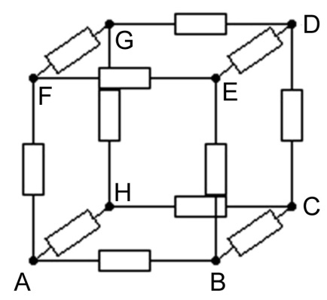

A to D
A
F
H
B
D
G
E
C
R/3 + R/6 + R/3 = 5/6 R = 83.3Ω

A
H
B
C
F
D
G
E
A to C
Since H,G,E and B are symetrically mid way between A and C they must be at the same potential i.e. midway between A and C therefore we can ignore resistors GH and BE as no current will flow. AHC = 200Ω, ABC = 200Ω so combined that is 100Ω, F to D is 100Ω by the same reasoning. The central paths give 100Ω + 100Ω + 100Ω = 300Ω which is in parallel with the combined outer paths of 100Ω. The total is therefore 75Ω or more generally 3/4 R.

A to B
A
F
H
B
D
G
E
C
Blue = 50+100+50 = 200Ω Yellow = 100/2 = 50Ω Combined = 40Ω
Green = 100/2 = 50Ω so total for shaded routes = 50+40+50=140Ω
So total for whole network = 140Ω in parallel with 100Ω = 58.3Ω
Or more generally 7/12 R

