Determining the Planck constant using LEDs

Introduction
In this experiment, you will measure the minimum p.d. across a number of light-emitting diodes which will just cause each diode to emit photons of light. You will then process the data and derive a value for the Planck constant.
At the junction of the p-type and n-type semiconductors in a light-emitting diode, electrons in the n-type material receive energy from the cell and are able to jump into the holes in the p-type semiconductor, enabling the diode to conduct. In doing so, they emit photons of light.
The minimum energy of an electron of charge, e, moving through a p.d., V, is given by the product of charge and p.d. (eV) that is just converted into a photon energy hc/λ, where λ is the wavelength of the emitted light photon, c is the speed of light in a vacuum and h is the Planck constant is given by
eV = hc / λ
Aim
- To determine a value for the Planck constant
Intended class time
- 60 to 90 minutes

Equipment
- a variety of different coloured light-emitting diodes (LEDs)
- connecting leads
- two cells or power supply limited to 3V
- rheostat for use as a potential divider
- digital voltmeter
- card or black paper

Health and safety
- The focussed beam of certain LEDs can be damaging or irritating to the eyes. Do not look directly at an LED at full intensity.

- The major risk to equipment is damaging the LED with excessive current. Consider how this risk can be reduced.

Procedure
- Connect the rheostat to the power supply so that the output p.d. measured by the voltmeter across the rheostat is variable and in the approximate range of 0 to 3 V.
- Set the output p.d. to about 0.5 V.

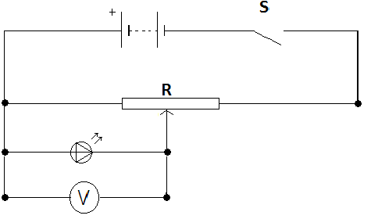
- Connect one of the LEDs to the output p.d. and adjust the rheostat to increase the p.d. until the LED just starts to conduct (as judged by the LED just producing a faint glow). Viewing the LED through a tube of matt black paper or card reduces the interfering light level, and allows this judgement to be carried out more precisely.
- Record the values of minimum p.d. required to produce light and the corresponding wavelength of the light emitted.
- Plot a graph of minimum p.d. against 1 / λ draw a ‘best fit’ line.
- Find the gradient of your graph and hence determine a value for the Planck constant.

Extension Opportunities
- Draw error bars on your graph or draw a worst acceptable line of best fit.
- Calculate the gradient of this line and hence a worst acceptable value for the Planck constant.
- Give a final answer for the Planck constant with a tolerance within which there is confidence that the value lies.
- Research a value for the Planck constant. Quote your sources.
- Calculate the percentage difference between your value for the Planck constant and the researched value.
- Comment on the accuracy of your experiment.

Recording
As evidence for the Practical Endorsement you should have the measurements collected in a clear and logical format. All work should be clearly dated.

In addition, in preparation for the assessment of practical work in the written examinations and to help you develop your understanding, you should have used the data collected to calculate a value for the Planck constant, explaining clearly how you have used the data in the calculation and showing all working.
You should calculate the accuracy as detailed and comment on your findings.

