Practical Endorsement

Students who demonstrate the required standard across all the requirements of the CPAC, incorporating all the skills, apparatus and techniques (as defined in Sections 1.2.1 and 1.2.2), will receive a ‘Pass’ grade. In order to achieve a pass, students will need to:

• develop these competencies by carrying out a minimum of 12 practical activities (PAG1 to PAG12), which allow acquisition of all the skills, apparatus and techniques outlined in the requirements of the specification (Sections 1.2.1 and 1.2.2)

• consistently and routinely exhibit the competencies listed in the CPAC before the completion of the A-level course

• keep an appropriate record of their practical work, including their assessed practical activities.

• be able to demonstrate and/or record independent evidence of their competency, including evidence of independent application of investigative approaches and methods to practical work.

Students may work in groups but teachers who award a pass to their students need to be confident of individual students’ competence. Each student will keep an appropriate record of their practical work, including their assessed practical activities.

1.2.1 Practical skills

Independent thinking
(a) apply investigative approaches and methods to practical work
Use and application of scientific methods and practices
(b) safely and correctly use a range of practical equipment and materials
(c) follow written instructions
(d) make and record observations/measurements
(e) keep appropriate records of experimental activities
(f) present information and data in a scientific way
(g) use appropriate software and tools to process data, carry out research and report findings
Research and referencing
(h) use online and offline research skills including websites, textbooks and other printed scientific sources of information
(i) correctly cite sources of information
Instruments and equipment
(j) use a wide range of experimental and practical instruments, equipment and techniques appropriate to the knowledge and understanding included in the specification.

Through use of the apparatus and techniques listed below, and a minimum of 12 assessed practicals, learners should be able to demonstrate all of the practical skills listed within 1.2.1 and CPAC as exemplified through:

1.2.2 Use of apparatus and techniques

(a) use of appropriate analogue apparatus to record a range of measurements (to include length/ distance, temperature, pressure, force, angles and volume) and to interpolate between scale markings
(b) use of appropriate digital instruments, including electrical multimeters, to obtain a range of measurements (to include time, current, voltage, resistance and mass)
(c) use of methods to increase accuracy of measurements, such as timing over multiple oscillations, or use of fiduciary marker, set square or plumb line
(d) use of a stopwatch or light gates for timing
(e) use of calipers and micrometers for small distances, using digital or vernier scales
(f) correctly constructing circuits from circuit diagrams using DC power supplies, cells, and a range of circuit components, including those where polarity is important
(g) designing, constructing and checking circuits using DC power supplies, cells, and a range of circuit components
(h) use of a signal generator and oscilloscope, including volts/division and time-base
(i) generating and measuring waves, using microphone and loudspeaker, or ripple tank, or vibration transducer, or microwave/radio wave source
(j) use of a laser or light source to investgate characteristcs of light, including interference and diﬀracton
(k) use of ICT such as computer modelling or data logger with a variety of sensors to collect data, or use of sofware to process data
(l) use of ionising radiaton, including detectors.

Common Practical Assessment Criteria, CPAC
(1) Follows written procedures | a) Correctly follows instructions to carry out experimental techniques or procedures.
(2) Applies investigative approaches and methods when using instruments and equipment | a) Correctly uses appropriate instrumentation, apparatus and materials (including ICT) to carry out investigative activities, experimental techniques and procedures with minimal assistance or prompting.
 | b) Carries out techniques or procedures methodically, in sequence and in combination, identifying practical issues and making adjustments when necessary.
 | c) Identifies and controls significant quantitative variables where applicable, and plans approaches to take account of variables that cannot readily be controlled.
 | d) Selects appropriate equipment and measurement strategies in order to ensure suitably accurate results.
(3) Safely uses a range of practical equipment and materials | a) Identifies hazards and assesses risks associated with these hazards, making safety adjustments as necessary, when carrying out experimental techniques and procedures in the lab or field.
 | b) Uses appropriate safety equipment and approaches to minimise risks with minimal prompting.
(4) Makes and records observations | a) Makes accurate observations relevant to the experimental or investigative procedure.
 | b) Obtains accurate, precise and sufficient data for experimental and investigative procedures and records this methodically using appropriate units and conventions.
(5) Researches, references and reports | a) Uses appropriate software and/or tools to process data, carry out research and report findings.
 | b) Cites sources of information, demonstrating that research has taken place, supporting planning and conclusions.

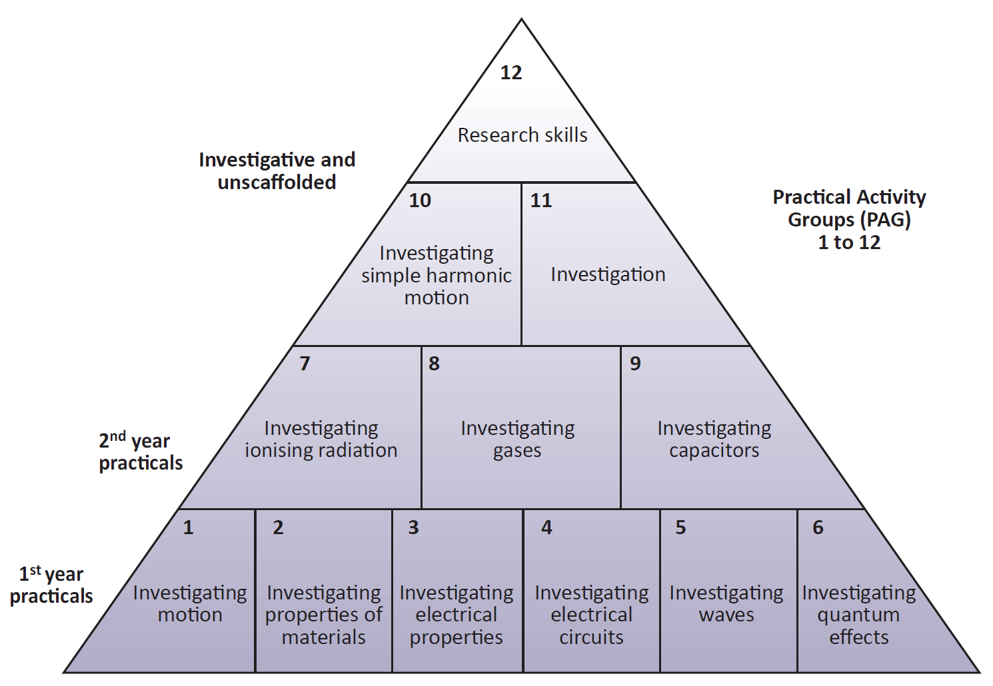
Table 1
1 Investigating motion | • Use of appropriate analogue apparatus to measure distance, angles¹, mass² and to interpolate between scale markings³  • Use of a stopwatch or light gates for timing  • Use of ICT such as computer modelling, or data logger with a variety of sensors to collect data, or use of software to process data⁴  • Use of methods to increase accuracy of measurements, such as set square or plumb line
2 Investigating properties  of materials | • Use of calipers and micrometers for small distances, using digital or vernier scales⁵  • Use of appropriate analogue apparatus to measure length⁶ and to interpolate between scale markings³  • Use of appropriate digital instruments to measure mass²
3 Investigating electrical  properties | • Use of appropriate digital instruments, including multimeters⁷, to measure current⁸, voltage⁹, resistance¹⁰  • Use calipers and micrometers for small distances, using digital or vernier scales⁵  • Correctly constructing circuits from circuit diagrams using DC power supplies, cells, and a range of circuit components
4 Investigating electrical  circuits | • Use of appropriate digital instruments, including multimeters⁷, to measure current⁸, voltage⁹, resistance¹⁰  • Correctly constructing circuits from circuit diagrams using DC power supplies, cells, and a range of circuit components, including those where polarity is important  • Designing, constructing and checking circuits using DC power supplies, cells, and a range of circuit components
5 Investigating waves | • Use of appropriate analogue apparatus to measure length⁶, angles¹ and to interpolate between scale markings³  • Use of a signal generator and oscilloscope, including volts/division and time-base  • Generating and measuring waves, using microphone and loudspeaker, or ripple tank, or vibration transducer, or microwave/radio wave source  • Use of a laser or light source to investigate characteristics of light, including interference and diffraction  • Use of ICT such as computer modelling
6 Investigating quantum  effects | • Use of appropriate digital instruments, including multimeters⁷, to measure current⁸, voltage⁹  • Correctly constructing circuits from circuit diagrams using DC power supplies, cells, and a range of circuit components, including those where polarity is important  • Use of a laser or light source to investigate characteristics of light, including interference and  diffraction  • Use of methods to increase accuracy of measurements
7 Investigating ionising  radiation | • Safe use of ionising radiation, including detectors  • Use of ICT such as computer modelling, or data logger with a variety of sensors to collect data, or use of software to process data⁴
8 Investigating gases | • Use of appropriate analogue apparatus to measure pressure, volume, temperature and to interpolate between scale markings³
9 Investigating capacitors | • Use of appropriate digital instruments, including multimeters⁷, to measure current⁸, voltage⁹,  resistance¹⁰  • Use of appropriate digital instruments to measure time  • Designing, constructing and checking circuits using DC power supplies, cells, and a range of circuit components  • Use of ICT such as computer modelling, or data logger with a variety of sensors to collect data, or use of software to process data⁴
10 Investigating simple  harmonic motion | • Use of appropriate digital instruments to measure time  • Use of appropriate analogue apparatus to measure distance and to interpolate between scale markings³  • Use of methods to increase accuracy of measurements, such as timing over multiple  oscillations, or use of fiduciary marker, set square or plumb line  • Use of ICT such as computer modelling, or data logger with a variety of sensors to collect data, or use of software to process data⁴
11 Investigation | • Apply investigative approaches and methods to practical work
12 Research skills | • Use online and offline research skills  • Correctly cite sources of information

PAG Activities
Students must complete at least one (or suitable alternative) from each row to be awarded a pass.
 |  | 1 | 2 | 3
1 | Investigating Motion | Comparing methods of determining g | Investigating terminal velocity | Investigating the effect of initial speed on stopping distance
2 | Investigating properties of Materials | Determining the Young modulus for a metal | Force/extension characteristics for arrangements of springs | Investigating a property of plastic
3 | Investigating Electrical Properties | Determining the resistivity of a metal | Investigating Electrical Characteristics | Determine the internal resistance of a cell/Maximum power theory
4 | Investigating electrical circuits | Investigating resistance | Investigating circuits with more than one source of e.m.f. | Investigating potential divider circuits including a non-ohmic device
5 | Investigating waves | Determining the wavelength of light with a diffraction grating or CD | Determining the speed of sound in air using a resonance tube | Determining frequency and amplitude of a wave using an oscilloscope
6 | Investigating quantum effects | Determining the Plank constant | Experiments with light | Experiments with polarisation
7 | Investigating ionizing radiation | Investigating the random nature of radioactive decay | Investigating the absorption of α, β, and γ by appropriate materials | Investigating the half-life of radioactive materials
8 | Investigating Gases | Estimating absolute zero from gas pressure and volume | Investigating the relationship between pressure and volume | Estimating the work done by a gas as its temperature increases
9 | Investigating Capacitors | Investigating the charging and discharging of capacitors | Investigating capacitors in series and parallel | Investigating factors affecting the capacitance of a capacitor
10 | Investigating Simple Harmonic Motion | Investigating factors affecting simple harmonic motion | Observing forced and damped oscillations | Comparing static and dynamic methods of determining spring stiffness
11 | Investigation | Investigating transformers | Determining the specific heat capacity of a material | Determining the magnetic field of a magnet
12 | Research Skills | Materials Presentation | Research Report | An appreciation of an aspect of How Science Works

The criteria for specification sections 1.2.1 and 1.2.2 and the CPAC can be covered by completing the following activities: 3.1, 5.1 and 5.2 or 5.3, 7.1 or 7.3, 10.1 or 10.2 or 10.3, 11.1 or 11.2 or 11.3.

